Homework 10 - Lab 06 - Implement Traffic Management

Task 1: Provision the lab environment

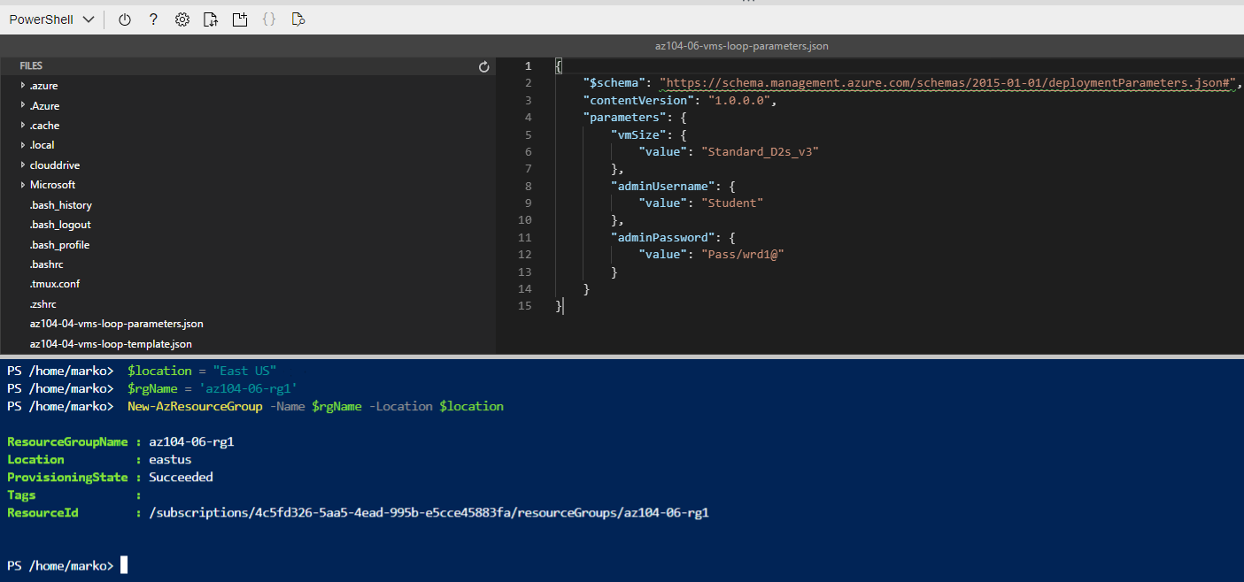

1. Making the required password edit in the JSON parameters file 2. Setting the location to East-us for the location of the new RG to be created, proceeding with the name RG name provided in the lab and creating the RG.

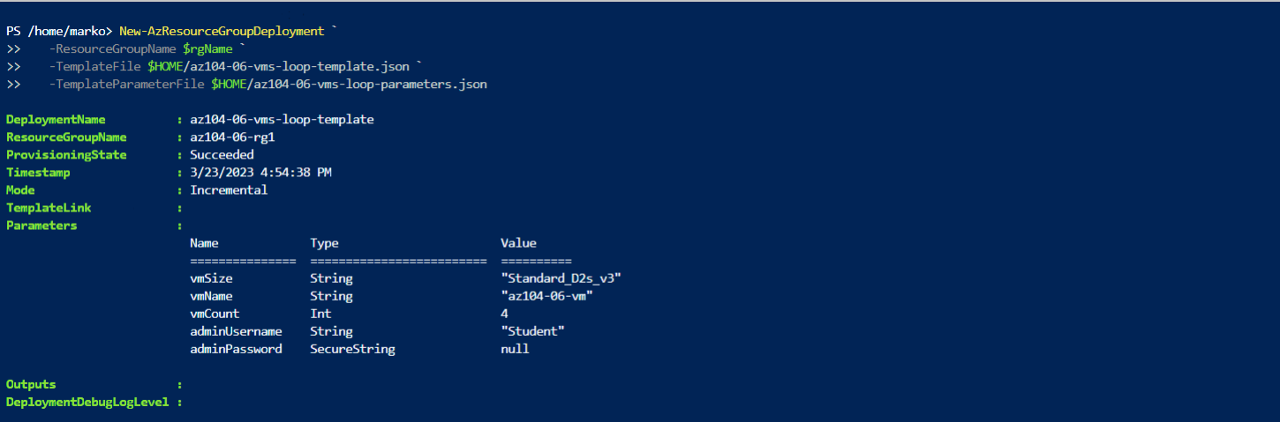

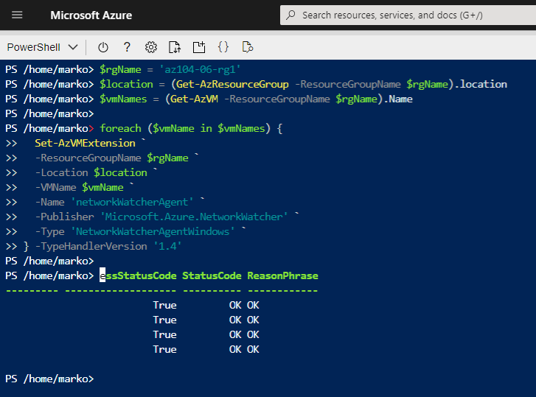

Installing network watcher extensions on each Azure VM deployed in the previous step.

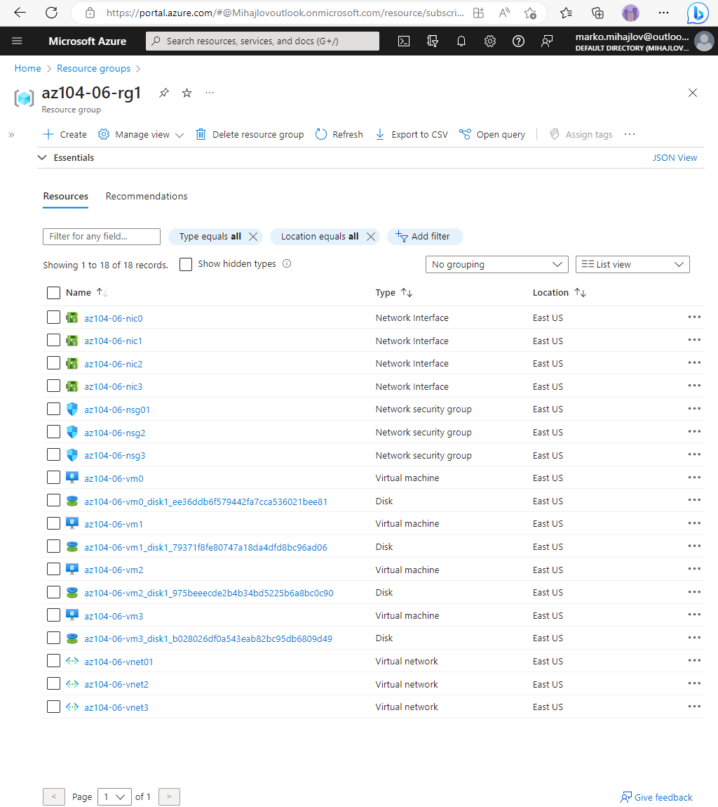

State of the resource group after running the above commands.

Task 2: Configure the hub and spoke network topology

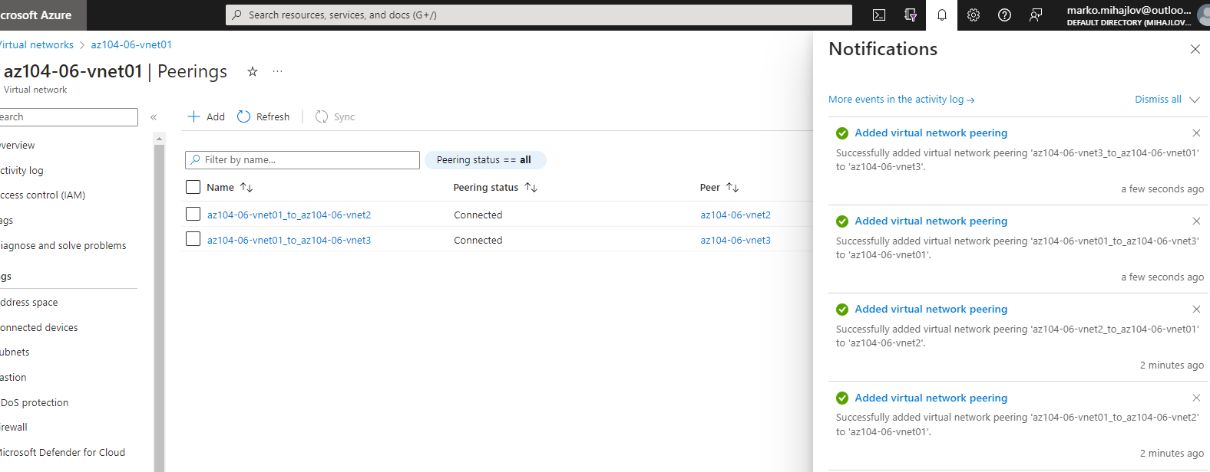

The created connections from vnet01 to vnet2 and vnet3 respectively. From the hub vnet01 to the spokes vnet2 and vnet3.

Task 3: Test transitivity of virtual network peering

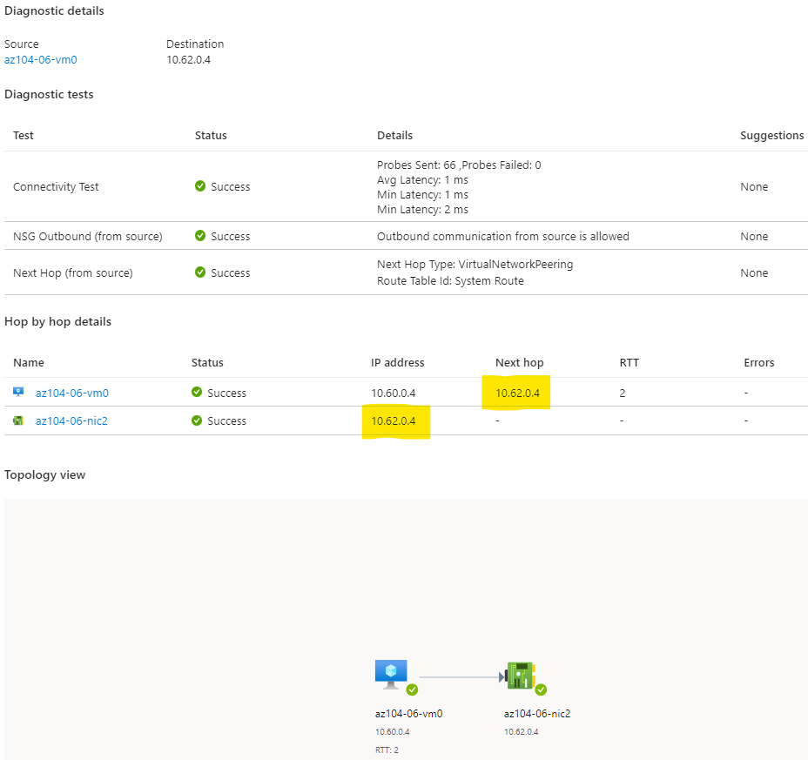

Confirming that connection is direct by examining the value from az104-06-vm0 from the value of the Next hop IP, which is the private IP of the network interface card of az104-06-vm2.

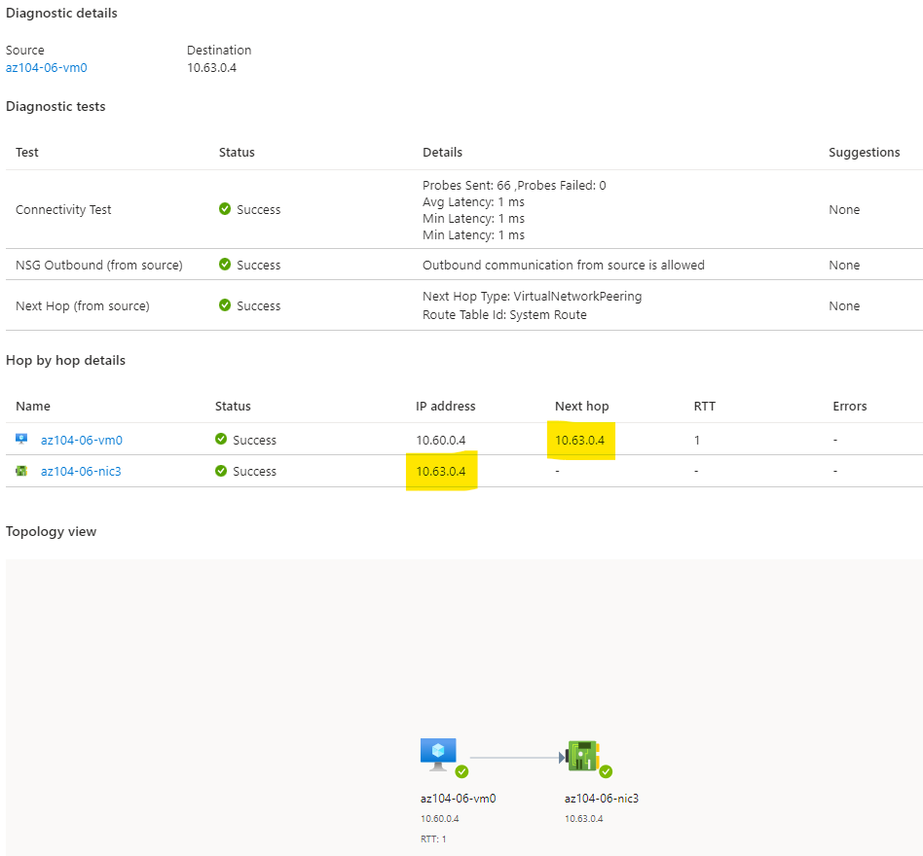

Confirming that connection is direct by examining the value from az104-06-vm0 from the value of the Next hop IP, which is the private IP of the network interface card of az104-06-vm3.

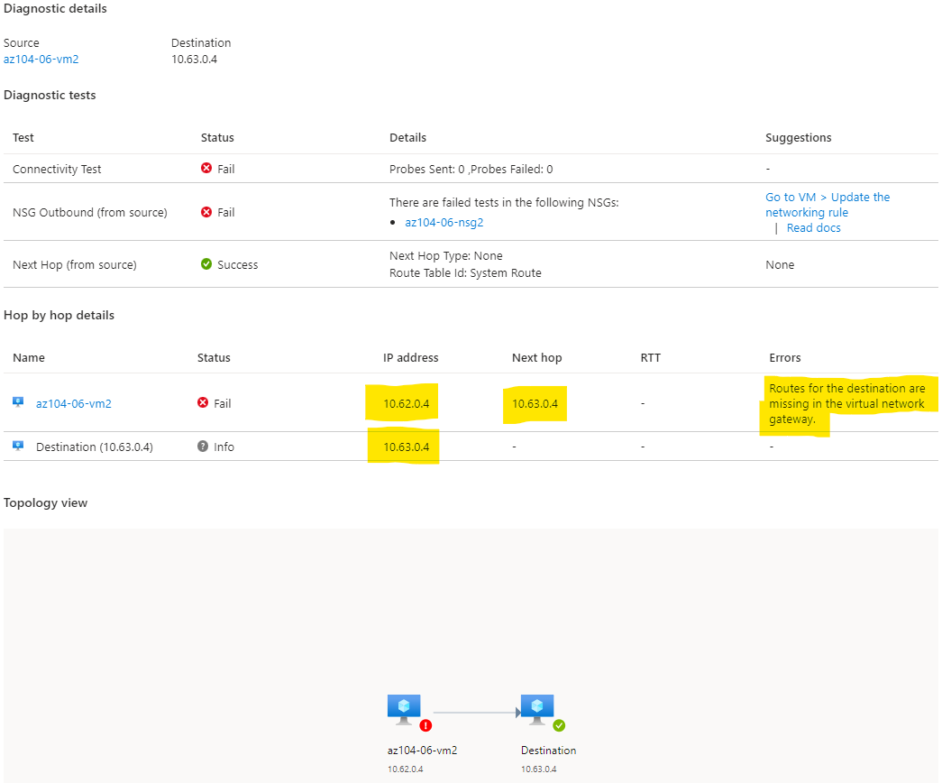

Attempting a connection between the 2 spoke networks (from vm2 to vm3) is not working at this point as the networks have not been peered with each other.

Task 4: Configure routing in the hub and spoke topology

After enabling IP forwarding on az104-06-vm0, we install several dependencies to enable routing on the first vm out to the other spoke networks and create and configure a routing tables ( and associate them both with subnet 0) with the following specs and add a single route in each of them.

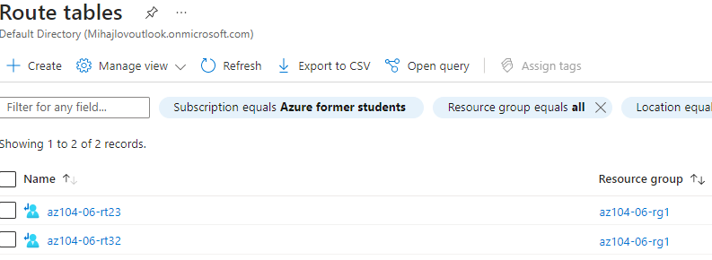

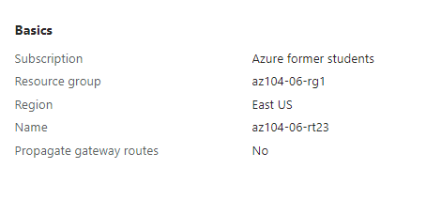

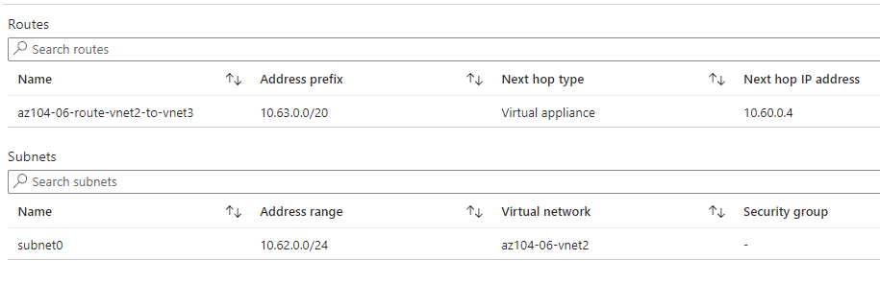

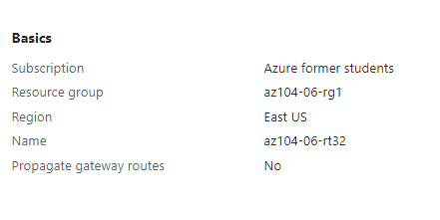

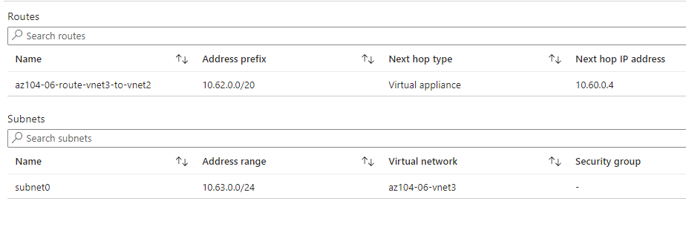

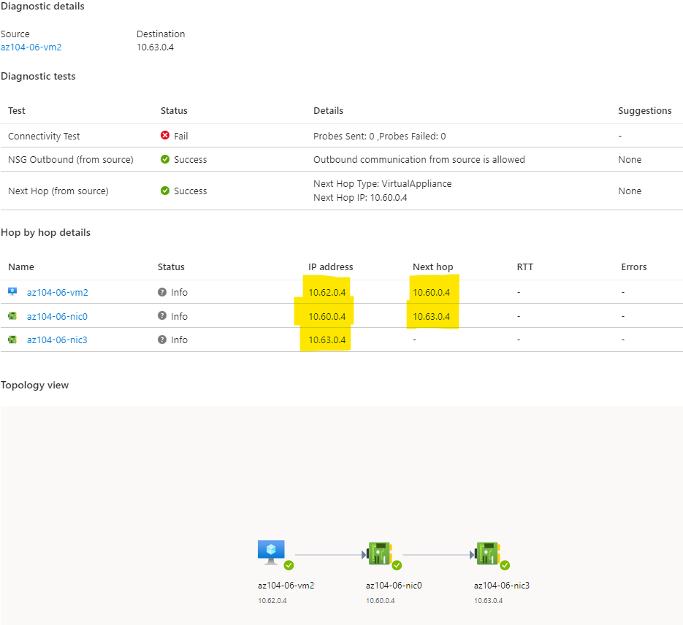

After the modifications in task 4 with establishing the routing tables the communication between vnet2 and vnet3 can now be established.

Task 5: Implement Azure Load Balancer ( load balance across virtual machines in the same virtual network, works on layer 4)

Creating a Load balancer in front of vne01 to route traffic to one or the other vm (vm0 or vm1) and associating it with vnet01(backend pool) – so the load balancer routes traffic to vm’s in the vnet.

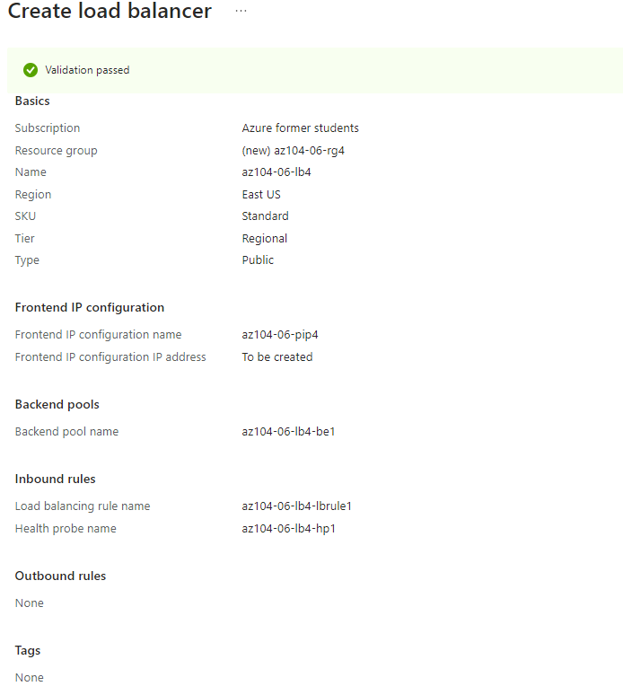

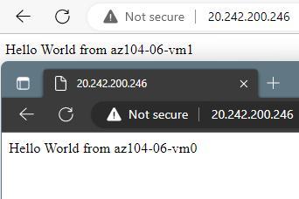

**When opening a new tab with the public IP of the load balancer - Hello World from az104-06-vm0** or **Hello World from az104-06-vm1**. Will appear, showing that the load balancer is operational and is directing traffic to one or the other vm in the associated vnet.

Task 6: Implement Azure Application Gateway ( can do load balancing + make routing decisions based on conditions –ex. incoming URL, if its one type its send via 1 path if its another its send via another path – works on layer 7).

Creating a subnet for the app gateway – as that Is a requirement from azure (Within your virtual network, a dedicated subnet is required for the application gateway. You can have multiple instances of a given application gateway deployment in a subnet. You can also deploy other application gateways in the subnet. But you can't deploy any other resource in the application gateway subnet.)

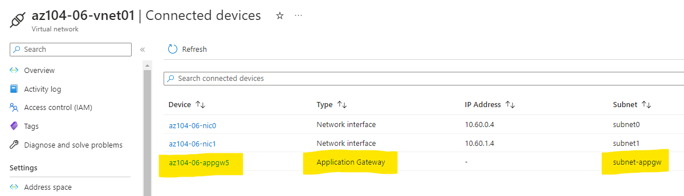

Creating an application gateway in front of the two spoke virtual networks to manage traffic for them.

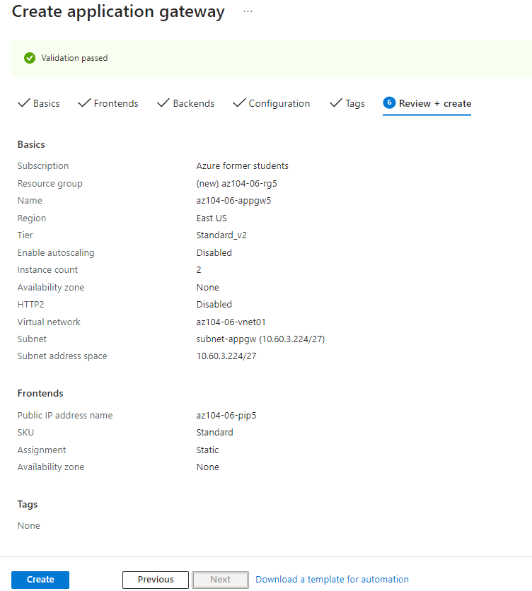

The application gateway is associated it with vnet01 (Subnet-appgw) and as a backend target the backend pool is set (the IP’s of vm3 and vm4) so the traffic is sent there based on the set routing rule.

Note from Azure: **Note**: Targeting virtual machines on multiple virtual networks is not a common configuration, but it is meant to illustrate the point that Application Gateway is capable of targeting virtual machines on multiple virtual networks (as well as endpoints in other Azure regions or even outside of Azure), unlike Azure Load Balancer, which load balances across virtual machines in the same virtual network.

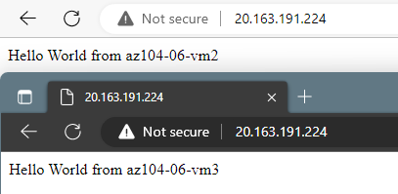

**When opening a new tab with the public IP of the application gateway - Hello World from az104-06-vm3** or **Hello World from az104-06-vm4**. will appear, showing that the application gateway is operational and is routing traffic to either vm.

End of file.